Figure 1 - Additional prostate biopsies stratified by age:

|  |  |  |  |  |  |  |
| --- | --- | --- | --- | --- | --- | --- |
| **Number of Additional Biopsies (%)** | **All patients** | **66-69 yrs** | **70-74 yrs** | **75-79 yrs** | **80-84 yrs** | **>=85 yrs** |
| **0** | 13956 (64.9) | 4940 (58.2) | 4728 (63.1) | 2751 (73.9) | 1111 (83.2) | 426 (91.6) |
| **1** | 5008 (23.3) | 2219 (26.1) | 1816 (24.2) | 754 (20.3) | 184 (13.8) | 35 (7.5) |
| **2** | 1726 (8.0) | 851 (10) | 675 (9) | 162 (4.4) | 35 (2.6) | 3 (0.6) |
| **3** | 542 (2.5) | 304 (3.6) | 193 (2.6) | 40 (1.1) | 4 (0.3) | 1 (0.2) |
| **4** | 187 (0.9) | 114 (1.3) | 60 (0.8) | 11 (0.3) | 2 (0.1) | 0 |
| **5** | 55 (0.3) | 37 (0.4) | 16 (0.2) | 2 (0.1) | 0 | 0 |
| **6** | 24 (0.1) | 17 (0.2) | 7 (0.1) | 0 | 0 | 0 |
| **7** | 9 (0) | 6 (0.1) | 2 (0) | 1 (0) | 0 | 0 |
| **8** | 5 (0) | 4 (0) | 0 | 1 (0) | 0 | 0 |

Figure 2 – Percentage of urinary retention and lower urinary tract symptoms within 30 days of the prostate biopsy and TURP among men stratified by age:

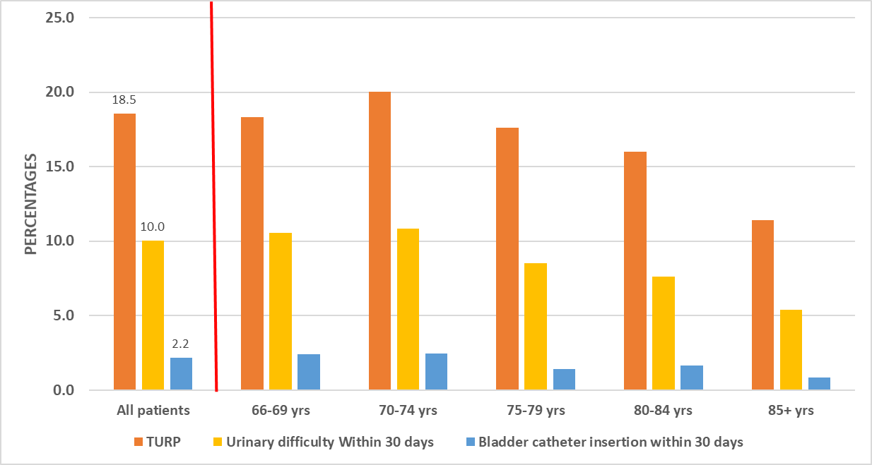

TURP = Transurethral resection of the prostate

Table 1 – Basic Demographic characteristics of all patients:

|  |  |  |  |  |  |  |
| --- | --- | --- | --- | --- | --- | --- |
|  | ***All patients*** | ***Age 66-69*** | ***Age 70-74*** | ***Age 75-79*** | ***Age 80-84*** | ***Age >=85*** |
| Number of men, (%) | 21,512 (100%) | 8,492 (39.5%) | 7,497 (34.8%) | 3,722 (17.3%) | 1,336 (6.2%) | 465 (2.2%) |
| Time-period, n (%)  1994-2000  2001-2007  2008-2014 | 12,131 (56.4%)  6,634 (30.8%)  2,747 (12.8%) | 4,281 (50.4%)  2,777 (32.7%)  1,434 (16.9%) | 4,317 (57.6%)  2,316 (30.9%)  864 (11.5%) | 2,360 (63.4%)  1,037 (27.9%)  325 (8.7%) | 863 (64.6%)  392 (29.3%)  81 (6.1%) | 310 (66.7%)  112 (24.1%)  43 (9.2%) |
| Mean ADG score, (SD) | 18.97 (11.62) | 16.85 (10.9) | 18.66 (11.28) | 21.44 (11.97) | 24.33 (12.09) | 27.49 (12.95) |
| Patients with medically-treated Diabetes, n (%) | 2,331 (10.8%) | 1,051 (12.4%) | 833 (11.1%) | 345 (9.3%) | 81 (6.1%) | 21 (4.5%) |
| Mean Rurality index (SD) | 11.63 (17.43) | 11.66 (17.38) | 11.78 (17.72) | 11.66 (17.34) | 11.05 (16.81) | 10.06 (16.09) |
| Income quintile, n (%)  1  2  3  4  5  Not available | 3,439 (16%)  4,167 (19.4%)  4,289 (19.9%)  4,356 (20.2%)  5,164 (24%)  97 (0.5%) | 1,260 (14.8%)  1,570 (18.5%)  1,655 (19.5%)  1,807 (21.3%)  2,165 (25.5%)  35 (0.4%) | 1,157 (15.4%)  1,470 (19.6%)  1,498 (20.0%)  1,500 (20.0%)  1,833 (24.4%)  39 (0.5%) | 686 (18.4%)  751 (20.2%)  759 (20.4%)  706 (19.0%)  805 (21.6%)  15 (0.4%) | 242 (18.1%)  277 (20.7%)  283 (21.2%)  260 (19.5%)  268 (20.1%)  6 (0.4%) | 94 (20.2%)  99 (21.3%)  94 (20.2%)  83 (17.8%)  93 (20.0%)  2 (0.4%) |

Table 2 - Cox proportional hazards multivariable regression model predicting the risk of bladder catheter insertion within 30 days of a prostate biopsy with medications modeled as ever vs. never and cumulative 6 months usage:

|  |  |  |  |  |
| --- | --- | --- | --- | --- |
|  | **Ever vs. Never** | | **Cumulative drug usage for 6 months** | |
|  | **HR (95% C.I)** | **p value** | **HR (95% C.I)** | **p value** |
| **Age Category (reference 66-69 years)** |  | | | |
| **70-74 years** | 1.045 (0.854-1.278) | 0.669 | 1.057 (0.864-1.292) | 0.587 |
| **75-79 years** | 0.728 (0.537-0.987) | 0.041 | 0.731 (0.539-0.991) | 0.04 |
| **80-84 years** | 1.039 (0.664-1.620) | 0.867 | 1.040 (0.669-1.636) | 0.839 |
| **>=85 years** | 0.700 (0.262-1.910) | 0.499 | 0.715 (0.264-1.936) | 0.51 |
| **ADG score (continuous variable)** | 1.003 (0.994-1.011) | 0.471 | 1.003 (0.994-1.011) | 0.477 |
| **Rurality index (continuous variable)** | 0.991 (0.985-0.997) | 0.006 | 0.991 (0.985-0.997) | 0.0046 |
| **Index Year (continuous variable)** | 0.966 (0.945-0.989) | 0.0035 | 0.968 (0.947-0.989) | 0.0039 |
| **Diabetes indicator** | 1.980 (1.443-2.716) | <0.0001 | 1.980 (1.450-2.720) | <0.0001 |
| **Cumulative num. of biopsies (continuous variable)** | 1.170 (1.055-1.297) | 0.0027 | 1.180 (1.069-1.312) | 0.0012 |
| **Glaucoma eye drops (yes vs. no)** | 0.817 (0.485-1.377) | 0.449 | 0.876 (0.701-1.094) | 0.243 |
| **5ARI (yes vs. no)** | 0.880 (0.633-1.22) | 0.452 | 0.976 (0.925-1.030) | 0.39 |
| **Alpha blockers (yes vs. no)** | 1.800 (1.434-2.263) | <0.0001 | 1.017 (0.988-1.048) | 0.234 |
| **Hydrophobic statins (yes vs. no)** | 1.23 (0.972-1.579) | 0.082 | 1.016 (0.993-1.040) | 0.151 |
| **Hydrophilic statins (yes vs. no)** | 0.561 (0.380-0.830) | 0.0038 | 0.952 (0.898-1.008) | 0.0966 |
| **PPIs (yes vs. no)** | 0.952 (0.864-1.05) | 0.330 | 0.977 (0.959-0.997) | 0.024 |

5ARIs= Five alpha reductase inhibitors, ADG = Johns Hopkins Aggregated Diagnosis Groups; PPIs = Proton pump inhibitors

Table 2 - Cox proportional hazards multivariable regression model predicting the risk of urinary difficulty within 30 days of a prostate biopsy with medications modeled as ever vs. never and cumulative 6 months usage:

|  |  |  |  |  |
| --- | --- | --- | --- | --- |
|  | **Ever vs. Never** | | **Cumulative drug usage for 6 months** | |
|  | **HR (95% C.I)** | **p value** | **HR (95% C.I)** | **p value** |
| **Age Category (reference 66-69 years)** |  | | | |
| **70-74 years** | 1.112 (1.011-1.224) | 0.029 | 1.126 (1.023-1.239) | 0.014 |
| **75-79 years** | 1.136 (0.997-1.293) | 0.054 | 1.144 (1.005-1.303) | 0.041 |
| **80-84 years** | 1.458 (1.184-1.796) | 0.0003 | 1.476 (1.1989-1.817) | 0.0002 |
| **>=85 years** | 1.660 (1.111-2.479) | 0.013 | 1.695 (1.135-2.531) | 0.009 |
| **ADG score (continuous variable)** | 1.001 (0.997-1.005) | 0.390 | 1.001 (0.997-1.005) | 0.411 |
| **Rurality index (continuous variable)** | 1.003 (1.0009-1.005) | 0.006 | 1.003 (1.0007-1.005) | 0.010 |
| **Index Year (continuous variable)** | 1.066 (1.055-1.077) | <0.0001 | 1.069 (1.058-1.080) | <0.0001 |
| **Diabetes indicator** | 1.167 (1.003-1.358) | 0.044 | 1.185 (1.018-1.378) | 0.027 |
| **Cumulative num. of biopsies (continuous variable)** | 0.972 (0.924-1.023) | 0.283 | 0.989 (0.941-1.040) | 0.687 |
| **Glaucoma eye drops (yes vs. no)** | 1.012 (0.839-1.219) | 0.900 | 1.025 (0.980-1.071) | 0.275 |
| **5ARI (yes vs. no)** | 0.800 (0.705-0.907) | 0.0005 | 0.939 (0.920-0.959) | <0.0001 |
| **Alpha blockers (yes vs. no)** | 1.979 (1.800-2.176) | <0.0001 | 1.048 (1.038-1.058) | <0.0001 |
| **Hydrophobic statins (yes vs. no)** | 0.998 (0.902-1.105) | 0.980 | 1.0001 (0.990-1.009) | 0.983 |
| **Hydrophilic statins (yes vs. no)** | 0.859 (0.755-0.979) | 0.022 | 0.977 (0.960-0.995) | 0.016 |
| **PPIs (yes vs. no)** | 0.896 (0.804-0.998) | 0.046 | 0.994 (0.978-1.010) | 0.509 |

5ARIs= Five alpha reductase inhibitors, ADG = Johns Hopkins Aggregated Diagnosis Groups; PPIs = Proton pump inhibitors

Table 4 - Cox proportional hazards multivariable regression models predicting the risk of undergoing TURP in men with a single negative prostate biopsy who were not diagnosed with prostate cancer during the study period with medications modeled as ever vs. never and cumulative 6 months usage:

|  |  |  |  |  |
| --- | --- | --- | --- | --- |
|  | **Ever vs. Never** | | **Cumulative drug usage for 6 months** | |
|  | **HR (95% C.I)** | **p value** | **HR (95% C.I)** | **p value** |
| **Age Category (reference 66-69 years)** |  | | | |
| **70-74 years** | 1.053 (0.968-1.145) | 0.225 | 1.064 (0.978-1.157) | 0.145 |
| **75-79 years** | 1.011 (0.906-1.128) | 0.884 | 1.017 (0.911-1.34) | 0.764 |
| **80-84 years** | 1.027 (0.856-1.230) | 0.774 | 1.040 (0.868-1.247) | 0.666 |
| **>=85 years** | 0.961 (0.685-1.349) | 0.820 | 0.988 (0.704-1.387) | 0.948 |
| **ADG score (continuous variable)** | 0.999 (0.996-1.003) | 0.853 | 0.999 (0.996-1.002) | 0.747 |
| **Rurality index (continuous variable)** | 1.003 (1.0007-1.005) | 0.008 | 1.002 (1.0005-1.005) | 0.0155 |
| **Index Year (continuous variable)** | 0.916 (0.908-0.925) | <0.0001 | 0.930 (0.922-0.938) | <0.0001 |
| **Diabetes indicator** | 1.149 (0.975-1.353) | 0.096 | 1.159 (0.984-1.365) | 0.076 |
| **Cumulative num. of biopsies (continuous variable)** | 1.190 (1.130-1.252) | <0.0001 | 1.251 (1.190-1.315) | <0.0001 |
| **Glaucoma eye drops (yes vs. no)** | 0.962 (0.783-1.181) | 0.713 | 0.962 (0.892-1.039) | 0.331 |
| **5ARI (yes vs. no)** | 1.523 (1.345-1.721) | <0.0001 | 0.982 (0.962-1.003) | 0.104 |
| **Alpha blockers (yes vs. no)** | 2.632 (2.403-2.884) | <0.0001 | 1.070 (1.058-1.081) | <0.0001 |
| **Hydrophobic statins (yes vs. no)** | 0.954 (0.858-1.060) | 0.388 | 1.006 (0.994-1.018) | 0.286 |
| **Hydrophilic statins (yes vs. no)** | 0.991(0.862-1.139) | 0.899 | 1.009 (0.988-1.029) | 0.387 |
| **PPIs (yes vs. no)** | 0.942 (0.840-1.056) | 0.306 | 0.980 (0.958-1.004) | 0.099 |

5ARI = Five alpha reductase inhibitors, ADG = Johns Hopkins Aggregated Diagnosis Groups; PPIs = Proton pump inhibitors; TURP = Transurethral resection of the prostate

**Supplemental table 1 – Data sources used from the Institute of clinical evaluative sciences:**

|  |  |  |
| --- | --- | --- |
| **Database** | **Used for** | **Reference** |
| Ontario Health insurance program (OHIP) | Tracks claims paid to physicians, laboratories, and out-of-province providers | Chan B. Supply of physicians' services in Ontario. Hospital quarterly 1999; 3(2): 17 |
| Registered persons database (RPDB) | Contains information on persons registered under OHIP and persons who are eligible for the Ontario Drug Program (over 65 years old) | Ontario Ministry of Health and Long-Term Care  Health System Information Management and Investment Division. Health Analyst’s Toolkit. Health Analytics Branch Winter 2012 |
| Canadian Institute for Health Information Discharge Abstract Database (CIHI-DAD) | Contains in-patient hospitalization data | Clarke E ML, Kreiger N. Cancer registration: principles and methods. Lyon, France: IARS Scientific Publications; 1991. |
| Ontario Drug Benefit database (ODB) | Includes data on all drug prescriptions for patients older than 65 in Ontario | Levy AR, O'Brien BJ, Sellors C, Grootendorst P, Willison D. Coding accuracy of administrative drug claims in the Ontario Drug Benefit database. The Canadian journal of clinical pharmacology = Journal canadien de pharmacologie clinique 2003; 10(2): 67-71. |

Supplemental table 2 – Source databased and Ontario Heath Insurance Plan (OHIP) database and the Canadian Classification of Diagnostic, Therapeutic, and Surgical Procedures (CCP) codes used to identify disease state and procedures:

|  |  |
| --- | --- |
| **Procedure** | **Code** |
| **Ontario Health Insurance Plan Database** | |
| Prostate biopsy | Z712, Z713, S644, E780 |
| Pelvic/abdominal ultrasound | J128, J135, J138, J149, J162, J180 |
| Radiation therapy for prostate cancer (pelvis-specific) | X336, X310, X311, X312, X313, X322 |
| Brachytherapy | S640 till 2007, afterwards X323, X324, X325 |
| Implantation of hormone pellets | G342 |
| **Canadian Institute of Health Information Discharge Abstract Database** | |
| Bilateral orchiectomy | CCP Code: 74.31; CCI Code: 1QM89 |
| Radical prostatectomy | CCP: 72.4, CCI: 1QT91 |

Supplementary Figure 1 - Use of commonly prescribed medications among men in the study: